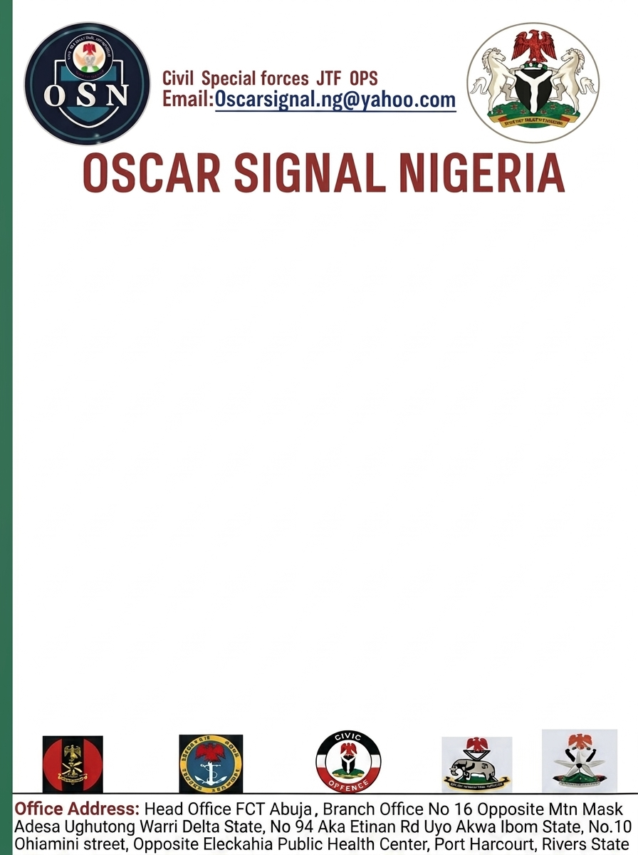

6/11/2026

The Commissioner of Police Nigeria Police Force
Rivers State Command State Headquarters,
Port Harcourt, Rivers State.
LETTER OF INTRODUCTION, PARTNERSHIP AND COURTESY VISIT
Ma/Sir,
On behalf of the National Executive Council (NEC) of Oscar Signal Nigeria (OSN), I respectfully write to formally introduce our organisation to your esteemed Command and to seek the opportunity for a courtesy visit and mutually beneficial partnership with the Nigeria Police Force, Rivers State Command.
I am also pleased to formally introduce Anthony Sorbari Yowika, who has been appointed and recognised as the Commandant, Oscar Signal Nigeria (OSN), Rivers State Command. He is entrusted with the responsibility of coordinating the affairs and activities of OSN within Rivers State and will serve as the organisation's principal representative in the State for official engagements and collaborations.
Oscar Signal Nigeria (OSN) is a duly registered incorporated organisation, having fulfilled the requirements prescribed under the Companies and Allied Matters Act (CAMA), Laws of the Federation of Nigeria, with its Certificate of Incorporation issued by the Corporate Affairs Commission (CAC), Registration No. CAC/IT/NO 7999684.

The organization has a national structure covering the six geopolitical zones of Nigeria, with zonal and state structures across the 36 states of the Federation and the Federal Capital Territory.
Our areas of operation include intelligence and information gathering, monitoring services, onshore and offshore services, evacuation support, civil services, and security-related support for cargo and vessels within Nigeria's territorial waters, subject to applicable laws and regulations.
In recognition of the vital role of the Nigeria Police Force in maintaining law and order, protecting lives and property, and promoting peaceful communities, OSN is desirous of establishing a professional and mutually beneficial working relationship with your esteemed Command.
Accordingly, we respectfully seek the privilege of paying a courtesy visit to your office at a date and time convenient to you. The visit will provide an opportunity to formally present OSN and its newly appointed Rivers State Commandant, discuss areas of possible collaboration, and seek your guidance and support for a productive relationship between both organizations.
We are confident that such cooperation will promote effective communication, responsible engagement and collective efforts towards supporting peace, security and community development within Rivers State.
We respectfully look forward to your favourable consideration and kind acceptance of our proposed courtesy visit.
Thank you for your anticipated cooperation and support.
Yours faithfully,
Signed,
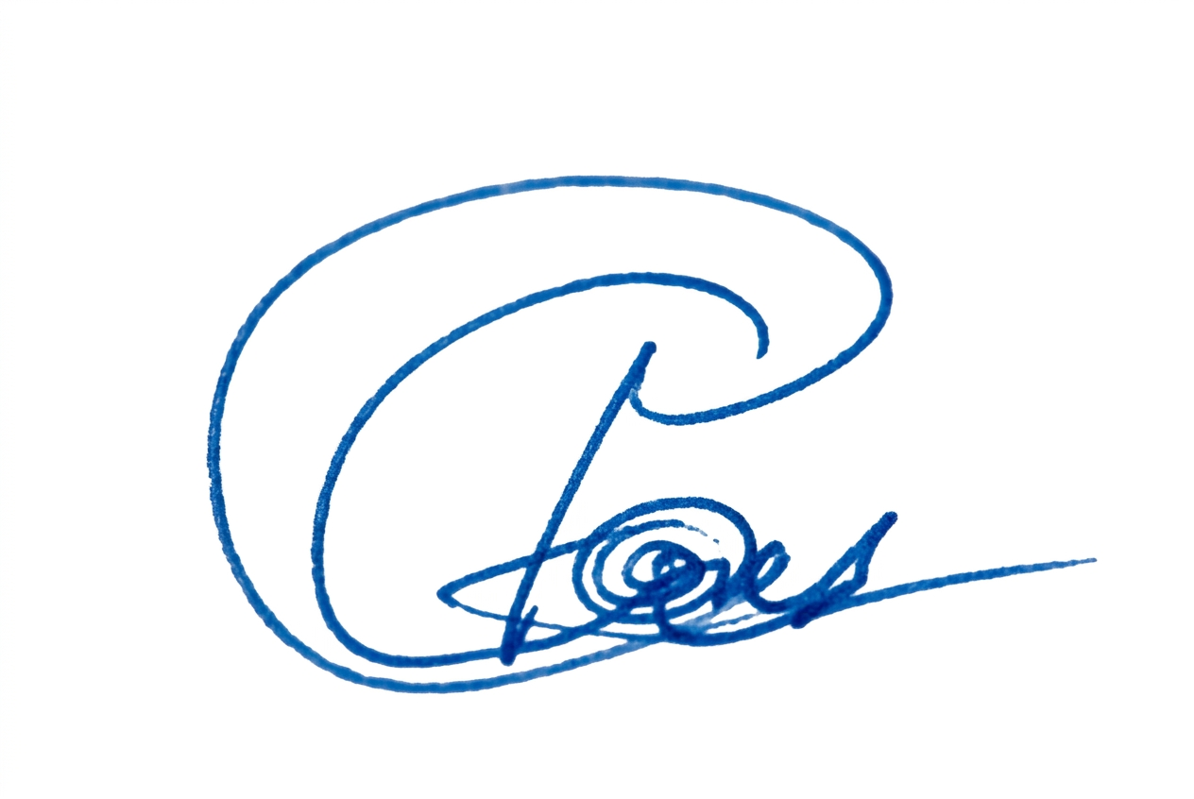
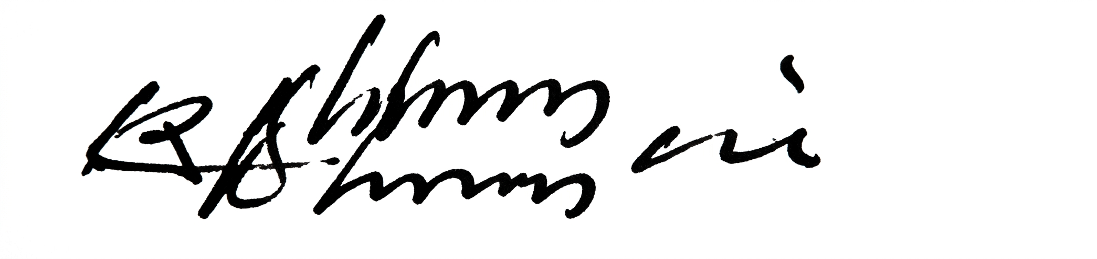
France Ikechukwu Engr. Dennis Kari
Commandant General (CG) B.O.T National Secretary
07013132589 For: National Executive Council (NEC)
08036695978
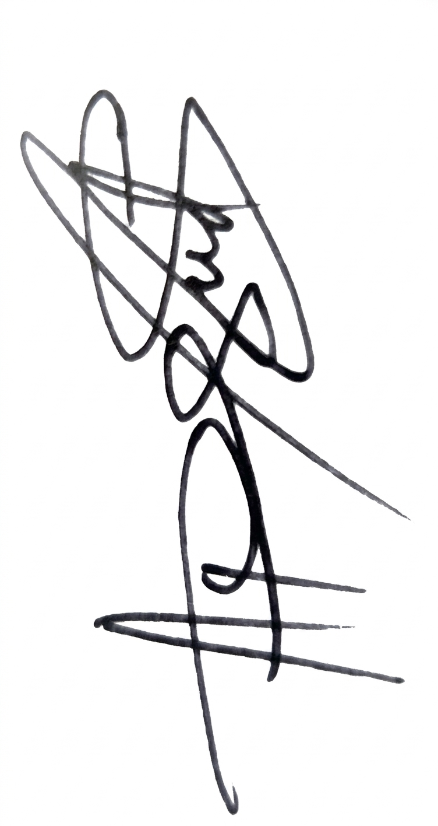


Robert Ekemini Anthony Sorbari Yowika
Deputy Commandant General/ Rivers State Commandant
National Operation Controller Oscar Signal Nigeria (OSN),
08083470347 Rivers State Command.
08038857096

